Message from The Headteacher
Dear Parents/ Guardians,

I would like to invite you to our first parent evenings of the school year. The parent evenings are being held after school on Tuesday 17th and Wednesday 18th October. Teachers will be sending appointments slips out today. I hope you can all attend and enjoy finding out how your child has settled into their new school year.

For parents who are unable to make the parent evenings and would like to organise an alternative appointment please speak to your child’s class teacher.

As we approach half term I would like to provide you with an update on the annex and the before and after school provision. The school’s TUPE advisors are currently guiding the school through the correct process. A Governors’ working party has been established and it is hoped that once the school has agreed all the relevant documentation this can be forwarded to the Playstation and the TUPE process can progress. Provision for before and after school provision will continue as normal until both parties have agreed the TUPE measures and a transfer date. When this process is nearing its conclusion I will inform parents of the transfer date and any other relevant information.

In response to a parental enquiry regarding pupil lateness, could I remind all parents that the school day starts at 8.45am. The school doors close at 8.50am and any child arriving after this time will enter the building via the main school office. Children entering the school through the main school office will be recoded as being late. Mr Hartford and/or Mr Timms are on the school yard to help direct any late children to the school office if and when required. The external school gates are locked at 8.55am and anybody entering or leaving the school after this time will do so via the main school entrance.
Could I also remind parents/guardians that it is ok to pass on brief messages to the teachers in the morning when they collect pupils from the yard, but not to use this as an opportunity to discuss more complex issues. Teachers need to be in their classrooms and ready to teach by 8.55am. If any parent/guardian has any issues/concerns that they feel would warrant a more lengthy conversation then please feel free to organise a more convenient time with the class teacher via the main school office.

I would like to thank the parents who attended the coffee evening on Tuesday 3rd October and putting forward a number of very constructive ideas and suggestions.

Last Friday the girl’s football team had a very close game against Menston Primary School. Both sides had good chances to score but unfortunately we narrowly lost 2 nil.
On Thursday night Year 5 had played netball and basketball against Burley Oaks Primary school.

The girls played superbly in the first half and ended only 3-2 down. In the second half the Burley shooters were really on form leading to a final score of 7-4 to Burley Oaks.

In the basketball the boys put in another outstanding team performance and comfortably beat Burley Oaks 23- 0. This magnificent win takes the team into the finals night next Thursday.

A big well done from Mr Hartford and all the staff.

Mr Hartford
Headteacher

Attendance for last week |  | Children with 100% attendance this half term
 |  |  | Wk 1 | Wk 2 | Wk 3 | Wk 4
Reception | 97% | Reception | 23 | 24 | 21 | 25
Year 1 | 99.5% | Year 1 | 28 | 27 | 28 | 29
Year 2 | 97.5% | Year 2 | 26 | 23 | 26 | 25
Year 3 | 98% | Year 3 | 30 | 27 | 29 | 28
Year 4 | 100% | Year 4 | 30 | 28 | 30 | 30
Year 5 | 99% | Year 5 | 29 | 27 | 30 | 25
Year 6 | 100% | Year 6 | 30 | 28 | 27 | 31
Total | 98% | Total | 196 | 184 | 191 | 193
Children who were late for school: 1 |  | Well done to all of you who have achieved this!

Learning Heroes
Congratulations to our learning heros for this week

Class | Learning hero | Reason
Year 1 | Sebastian Quaife | Always trying hard in every lesson
Year 2 | Iris Smith | For always doing the right thing
Year 3 | Kathryn Picken | For cooperating with others to help everyone’s learning
Year 4 | Nelson Muirhead | For ebin more focused, more sociable and for working hard
Year 5 | Alfie Roberts | Good person to create a piece of artwork and has improved in his classwork.
Year 6 | Cameron Leach | For his ability to reason his learning and for not being negatively impulsive
Caretaker Award Winners
For having the cleanest classroom

Your child will now have selected a brown luggage label with a non-perishable item on it for our Harvest Festival. The food bank desperately need to feed families in our own Bradford Community. If you would be as kind as to send the requested item into school by the day of the Harvest Festival Service at St. John's Church- Thursday 19th October; then we should be able to present the Food Bank with a big donation as part of the Harvest Festival Service.

We are delighted to share the news with you of the results of the Wharfedale Art Competition.

Ben Rhydding had winners – woo hoo!

Lower KS2 Individual Group:

First Prize: Through the Keyhole, Candyland: Leo Snedden, Angus Helliwell, Evie Higgs, Alex Pollard, Freya Hein and Lydia Green.

Second Prize: Through the Keyhole, Haunted: Luci Rodriguez, Jessie Browne, James Nice, Rachel Gibbons, Oisin Starr

Local artists Kerry Stoker, Linda Dewart and Joanne Tinker came into Ghyll Royd yesterday to blind judge the entries and were overwhelmed with the level of artwork on display.
All the artwork will be on show from Thursday until Sunday from 10.00am until 3.00pm so please encourage parents, staff and pupils to come along and see all the wonderful artwork on display.
Please, if possible, could the highlighted pupils and their parents if available, come along to the prize giving ceremony on Tuesday 10th October at 10.00am to collect their certificates!

Once again, we’d like to thank you for taking part in the first ever competition, part of the Ilkley Art Trail 2017. We hope to see you over the next few days!

As you are all aware we have now introduced parent pay for school meals. Shortly we will be adding school trips to allow you to pay online. You can do this by uploading money from your card, however if this option is not viable to you, you can use paypoint who are partners with parent pay.
To help you, here are a list of paypoint locations that you can go to:
United Coop – 22 Brook Street, Ilkley LS29 8DE
Co-op – Bolton Bride Road, Ilkley LS29 9EW
Co-op – 44 Main Street, Burley in Wharfedale, Ilkley LS29 7DN
The Co-operative – 162 Main Street, Addingham, Ilkley LS29 0LY
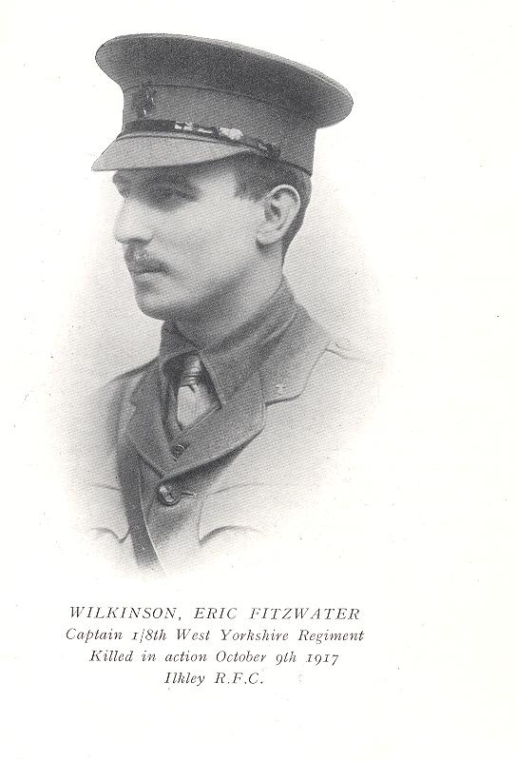
We are extremely proud to say that Years 5 and 6 will be exhibiting art work, poetry and letters inspired by Captain Eric Wilkinson (a local poet, who died 9th October 1917 fighting in WW1). The exhibition will be at the Ben Rhydding Methodist church over the weekend and is part of the Ilkley Art trail. Some of our work will be read out as part of a commemoration service on Sunday.
Mrs Leach will be holding a regular SEN drop-in, this year. The first, will be held on Wednesday 8th November (3.30-6.30pm) and repeated on Thursday 9th November (8.45-10.15am). For this first drop-in, she will have available, some of the interventions/resources we use in school for literacy difficulties. This is a great opportunity for you to see how we support Specific Literacy difficulties (e.g. Dyslexia) and to chat about the impact that these difficulties can have on accessing the curriculum. All are welcome.
Ashland’s Cross Country Saturday 30th September 2017
Congratulations to the 70 Ben Rhydding children who ran in the first of the Wharfedale cross country events organised by Ashland’s School. A particular well done to those children who were running their first ever race.
It was particularly pleasing to see so many teams and team placings achieved.
Team | Position | Team members
Reception Girls | 3rd Team | Harriet Carter, Nancy Crannigan, Frances Hess, Isla Moffat, Abigail Brewston
Year 2 Girls | 2nd Team | Iris Smith, Ella Walton, Sadie Eccles, Alice Gardiner, Abi Henderson, Nina Snedden.
Year 2 Boys | 2nd Team | Ben Winterbottom, James Hammond, Robert Carter, George Healey, Rupert Holmes, Charlie Eccles, Tom Moffat, Louis Foyston.
Year 3 Girls | 1st Team | Kitty Picken, Sophie White, Emily Wood, Alexa White, Olivia Buckingham, Holly Chapman, Isabelle De La Poer.
Year 3 Boys | 2nd Team | Ted Atkinson, Alex Rawse, Marrin Foulger, Joshua Nunns, Joshua Keeley, Samuel Hess.
Year 5 Boys | 3rd Team | Alexander Wolfenden, George Docherty, Callum Sawyer, Alex McKay, Benjamin Hammond, Woody Muirhead.
Year 6 Girls | 3rd Team | Lizzie Meredith, Evie Winterbottom, Natalie Snedden, Francesca Macina.
Year 6 Boys | 3rd Team | Jesse Pattinson, Thomas Finnett, Cassius Foulger, Cameron Leach
Congratulations to the following children who achieved an incredible top 5 position.
Race | Name | Position
Reception Girls | Harriet Carter | 1st
Reception Boys | Lucas Quaife | 2nd
Year 2 Girls | Iris Smith | 3rd
Year 2 Boys | Ben Winterbottom | 5th
Year 3 Girls | Kitty Picken  Sophie White  Emily Wood  Alexa White | 1st  2nd  4th  5th
Year 3 Boys | Ted Atkinson | 2nd
Year 5 Boys | Alexander Wolfenden | 2nd
I hope I haven’t missed anyone!
The next race is at Ghyll Royd on the 14th October, please see the Ilkley Harriers Junior website for full details and follow the cross country link and the Ben Rhydding event on the 11th November where we will also need parent helpers.
Running club takes place every Tuesday after school for any child who wants to improve their running in a structured but fun environment – KS1 must be accompanied.
On Saturday 14th October 2017 we are running the annual Ghyll Royd Open Cross Country event, this will count towards the Wharfedale Primary School’s League table.
Registration will be from 8.30 am onwards at the front of the school. We would like an adult to take responsibility for registering your school and collecting the race result numbers at the finish. These result sheets will need to be returned straight after each race to the front of the school. You may have as many individuals running as you wish, the first four in each category will be counted for the team prize and the first three individuals in each race will receive medals.
All course and schedule details for you and the parents are available at http://www.ilkleyharriers.org.uk/jh/07roydxcraces.html (please note earlier start times for KS1 children’s races).
The timings for the day are as follows:
KS1 Lower KS2 Upper KS2
Rec Girls 09.00 hrs Year 3 Girls 10.35 hrs Year 5 Girls 11.35 hrs
Rec Boys 09.10 hrs Year 3 Boys 10.45 hrs Year 5 Boys 11.45 hrs
Year 1 Girls 09.20 hrs Year 4 Girls 10.55 hrs Year 6 Girls 11.55 hrs
Year 1 Boys 09.30 hrs Year 4 Boys 11.05 hrs Year 6 Boys 12.05 hrs
Year 2 Girls 09.40 hrs
Year 2 Boys 09.50hrs
KS1 Prizegiving 10.00 hrs Lower KS2 Prizegiving 11.15 hrs Upper KS2 Prizegiving 12.15 hrs
Dates for your Diary
October
Wednesday 11^{th,} Thursday 12th, Friday 13th - Robinwood Residential Visit
Friday 13th- Year 6 Peace Museum school trip money to be paid
Tuesday 17th – 3.50pm until 5.30pm – Parents evening consultation
Tuesday 17th – PTA School Calendar (please see separate school comms)
Wednesday 18th – 4.00pm until 6.30pm – Parents evening consultation
Thursday 19th – Harvest Festival at Church
Monday 30th – Seasonal Influenza (Nasal Fluenz) Reception, Yr1, Yr2, Yr3 & Yr4
November
Wednesday 8th – SEN drop in meeting – 3.30pm – 6.30pm
Thursday 9th – SEN drop in meeting – 8.45am – 10.15am
Thursday 9th – Stay and Play – Reception Class - 9am – 10.15am
Friday 10th – PTA Reception Cake Sale
Tuesday 21st – Stay and Play – Reception Class - 9am – 10.15am
Sunday 26th – PTA Christmas Fayre
December
Tuesday 5th – PTA school disco (KS1 5pm - 6pm KS2 6.15pm – 7.15pm)
Thursday 7th – Stay and Play – Reception Class - 9am – 10.15am

January
Friday 12th – Stay and Play – Reception Class - 9am – 10.15am
Monday 22nd – Stay and Play – Reception Class - 9am – 10.15am

February
Wednesday 7th – Stay and Play – Reception Class - 9am – 10.15am
Tuesday 27th – Stay and Play – Reception Class - 9am – 10.15am

