|  |  |
| --- | --- |
|  | BEN RHYDDING PRIMARY SCHOOL  Bolling Road  Ben Rhydding  Ilkley L:S29 8QH  T: **+44 (0) 1943 431133**  F: **+44 (0) 1943 433479**  E: **office@benrhydding.bradford.sch.uk**  **www.benrhydding.ngfl.ac.uk**  Head Teacher: Mr G Hartford |

Dear Parents/Guardians 29th November 2017

It was brought to my attention late last week that the Sunday Times released their 2016-17 list of the country’s 2000 top performing state and independent schools in England - all ranked by their most recent examination results.

The Sunday Times state that with all the data they gather this list is the most comprehensive resource covering **elite** school performance in the UK.

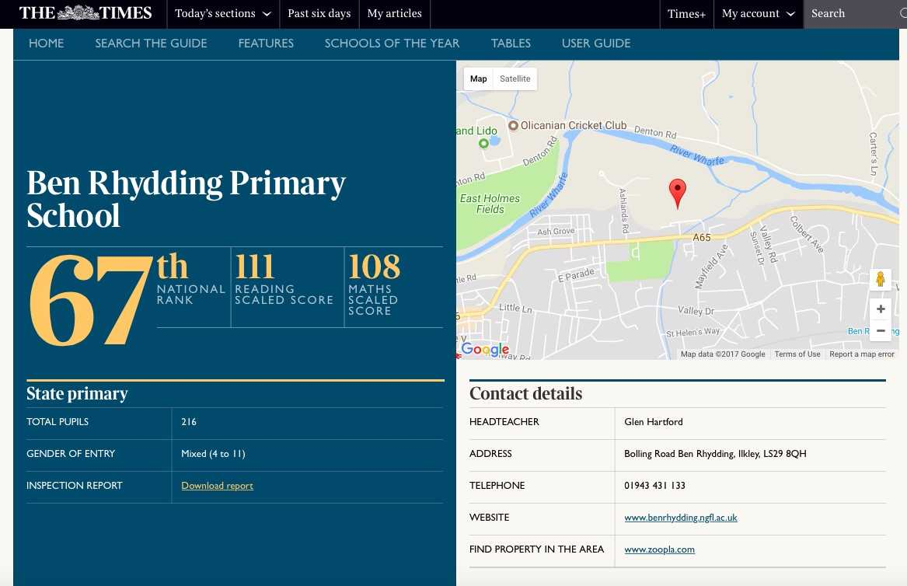

To compare schools, the newspaper took the progress that pupils make from the end of Key Stage 1 to the end of primary school (Key Stage 2) in reading, writing and maths separately. In this measure, pupils’ results are compared to the actual achievements of other pupils nationally who started at a similar level.

As you can see Ben Rhydding received a ranking of 67, this puts the school in the top 4% of the highest performing schools in the country. This is a remarkable achievement and is testament to all the hard work and outstanding teaching and learning that is being delivered by all the staff at Ben Rhydding Primary School.

It also reflects the dedication and support the school receives from our Governors, the PTA and all our pupils, parents and guardians. Without this support and the strong community spirit and involvement that surrounds the school, such an achievement would not have been possible. Thank you.

Kind regards

Mr G Hartford